SALES ANALYSIS DASHBOARD
Objectives of Project The primary objective of the project, which consists of sales order records from an organization, is to provide comprehensive insights into various aspects of the company's sales performance and operations. This data is crucial for informed decision-making and strategic planning.
Introduction: The dataset includes detailed information about sales transactions, including order dates, customer names, product details, sales amounts, profit margins, shipping modes, and regional data. By analyzing this data, the organization can achieve several key objectives: 1. Sales Performance Analysis: o Evaluate total sales and profits over time to identify trends and patterns. o Determine which products and categories contribute the most to sales and profit. o Identify top-performing sales regions and cities.
2. Customer Insights: o Analyze customer purchasing behavior to identify high-value customers. o Understand customer preferences by examining the most purchased products and categories.
3. Operational Efficiency: o Assess the impact of different shipping modes on sales and profit. o Monitor the distribution of sales by various shipping methods to optimize logistics.
4. Discount and Profitability Analysis: o Investigate the relationship between discount rates and profit margins. o Identify optimal discount strategies that maximize profitability.
5. Product Performance: o Identify top and bottom-performing products and categories to inform inventory and marketing strategies. o Analyze sub-category performance to uncover opportunities for product development or discontinuation.
6. Regional and Market Analysis: o Examine regional sales and profit data to identify market opportunities and challenges. o Use geographic data to support regional marketing and sales strategies.

TASK-1
- Create a chart showing total sales for each customer.
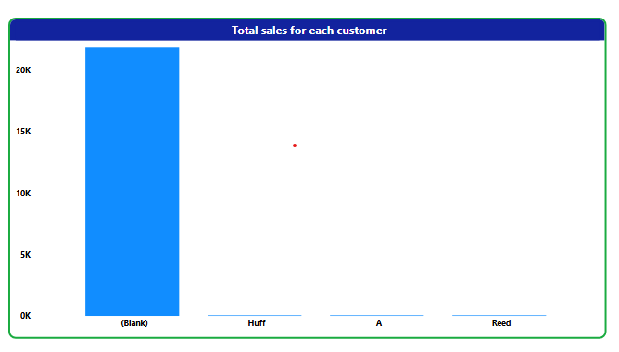
- Create a chart showing the total sales by month over the years.
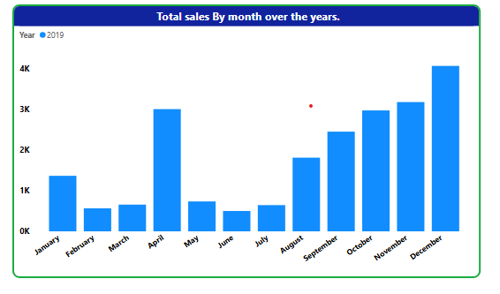
- Create a pie chart showing the distribution of sales by ship mode.
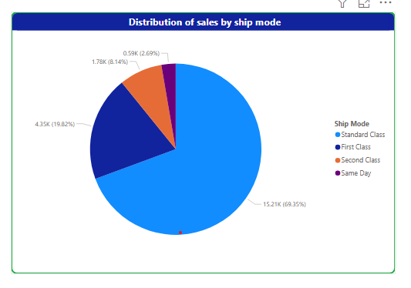

4Showing the total profit for each region.
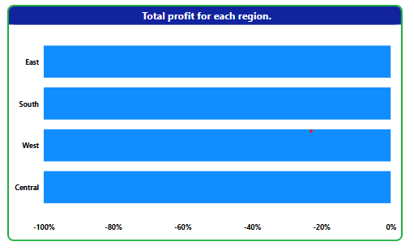
5Create a bar chart showing total sales and total profit for each product category.
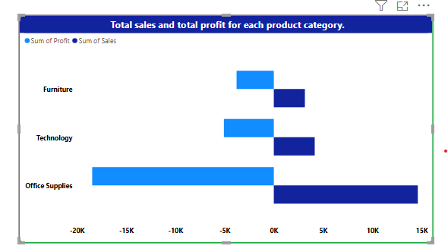
6Showing total sales for each product sub-category. 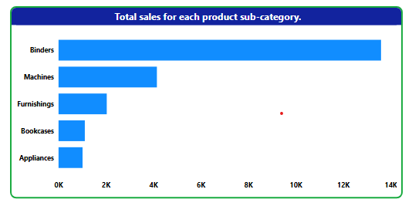

7. Create a chart with dual axes showing sales and quantity sold by order date.
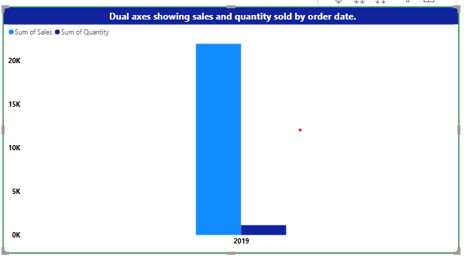
8. Showing the top 10 products by total sales.
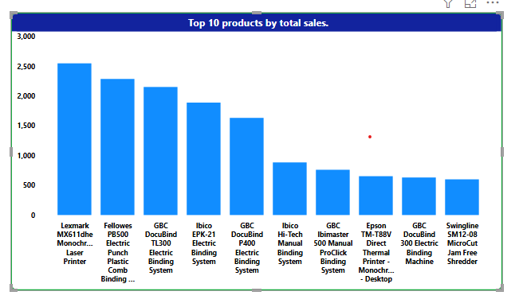
9. Create a map visualization showing total sales for each city.

10. Create a scatter plot showing the relationship between discount and profit.
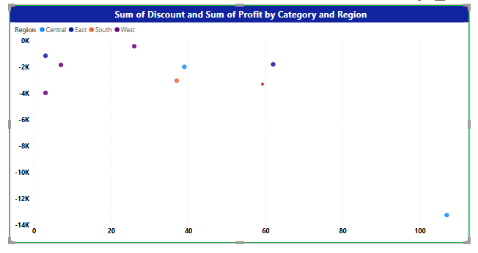

TASK-3
- Create a chart showing average sales for each customer.
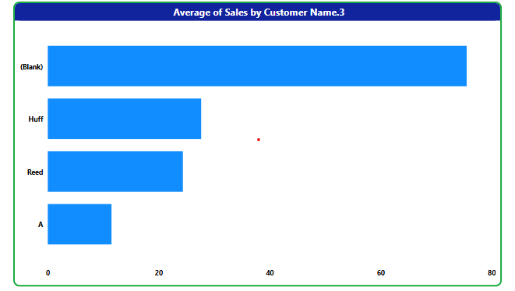
3. Create a chart showing sales by year and category.
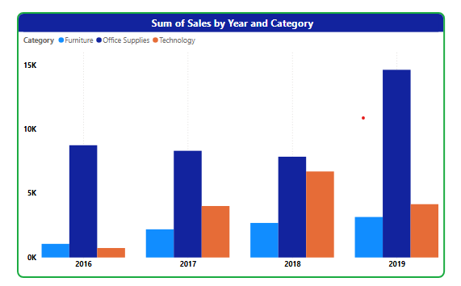
- Create a Visual showing the top 5 products by profit.
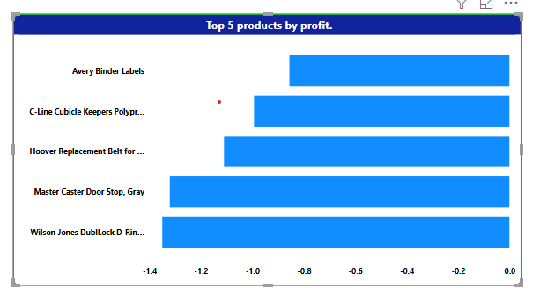

5Create a visual Showing average profit by product sub-category.
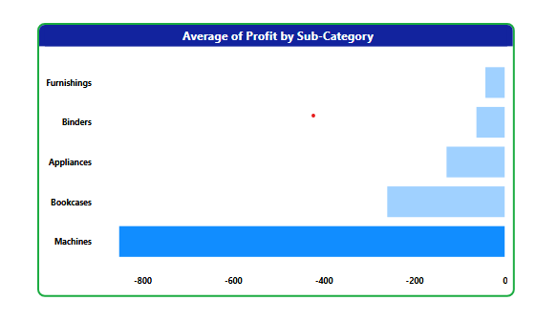
6Create a Line chart showing monthly sales trend for top 5 customers.
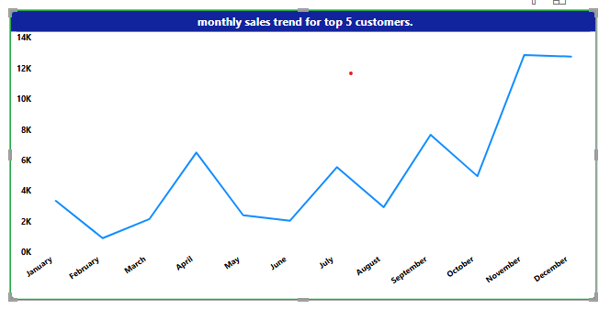
7. Create a chart showing sales contribution by region.
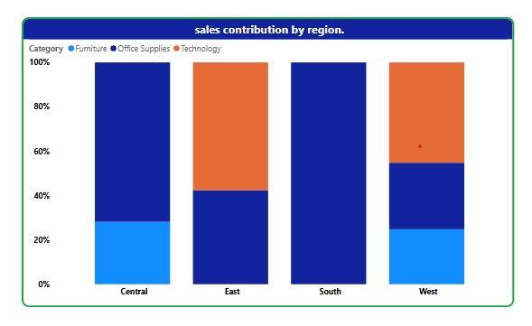
8. Create a chart showing total profit by month.
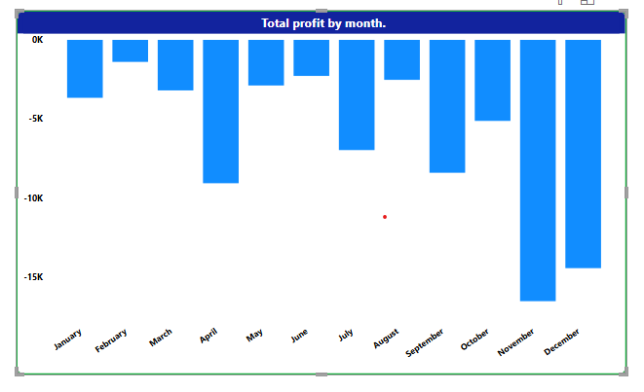
9. Create a chart showing average quantity sold by product category.
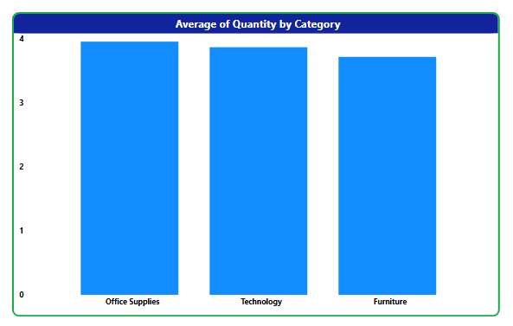
10. Create a Column chart showing sales by customer segment.
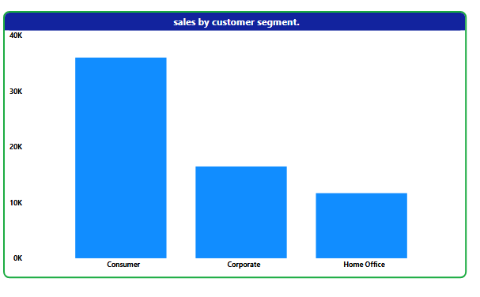
TASK-4 Use Power Query to filter orders with Order Date in 2019. a. Showing total sales for filtered orders.
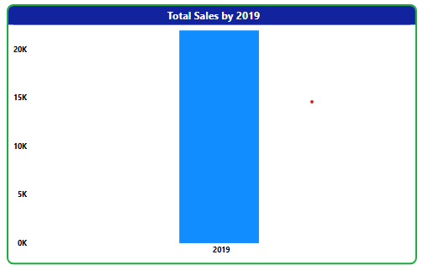
Add a column in Power Query for sales tax (10% of Sales). a. Create a chart showing total sales tax by product category.
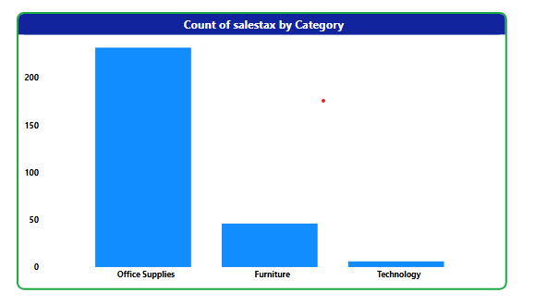
Split Customer Name into First Name and Last Name in Power Query. a. Create chart showing total Sles by first name.

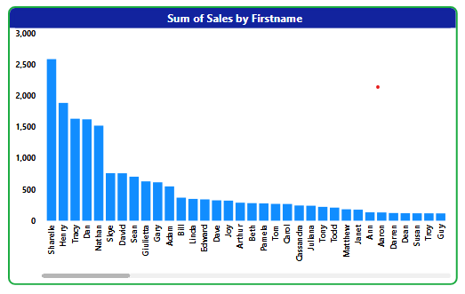
Create a custom column in Power Query for sales category (e.g., "High" for Sales > 100, "Low" otherwise). a. Create a Pie chart showing the distribution of sales categories.
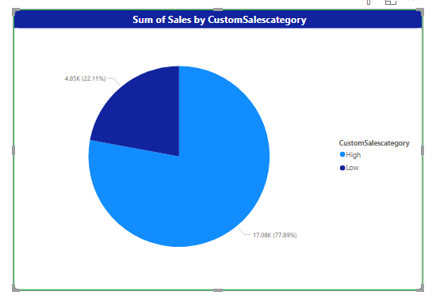

. Create a Line chart showing running total of sales over time.
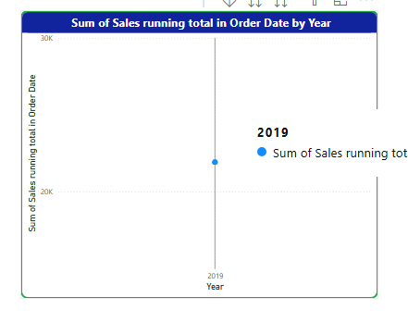

Dashboard

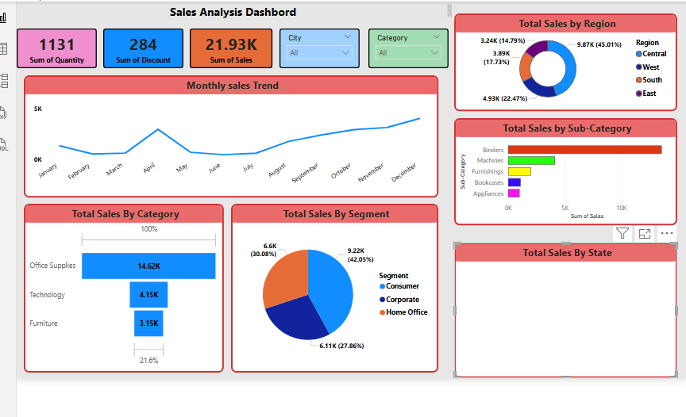

Tools and Technologies : POWER BI ,MS EXCEL

